Bootstrap 5 Containers

Bootstrap requires a containing element to wrap site contents.

Containers are used to pad the content inside of them, and there are two container classes available:

1. The .container class provides a responsive **fixed width container**
2. The .container-fluid class provides a **full width container**, spanning the entire width of the viewport

.container

.container-fluid

Fixed Container

Use the .container class to create a responsive, fixed-width container.

Note that its width (max-width) will change on different screen sizes:

|  | **Extra small <576px** | **Small ≥576px** | **Medium ≥768px** | **Large ≥992px** | **Extra Large ≥1200px** | **XXL ≥1400px** |
| --- | --- | --- | --- | --- | --- | --- |
| max-width | 100% | 540px | 720px | 960px | 1140px | 1320px |

Open the example below and resize the browser window to see that the container width will change at different breakpoints:

Example

<div class="container">  
  <h1>My First Bootstrap Page</h1>  
  <p>This is some text.</p>  
</div>

Fluid Container

Use the .container-fluid class to create a full width container, that will always span the entire width of the screen (width is always 100%):

Example

<div class="container-fluid">  
  <h1>My First Bootstrap Page</h1>  
  <p>This is some text.</p>  
</div>

Bootstrap 5 Grid System

Bootstrap's grid system is built with flexbox and allows up to 12 columns across the page.

If you do not want to use all 12 columns individually, you can group the columns together to create wider columns:

|  |  |  |  |  |  |  |  |  |  |  |  |
| --- | --- | --- | --- | --- | --- | --- | --- | --- | --- | --- | --- |
| span 1 | span 1 | span 1 | span 1 | span 1 | span 1 | span 1 | span 1 | span 1 | span 1 | span 1 | span 1 |
| span 4 | | | | span 4 | | | | span 4 | | | | |
| span 4 | | | | span 8 | | | | | | | | |
| span 6 | | | | | | span 6 | | | | | | |
| span 12 | | | | | | | | | | | | |

The grid system is responsive, and the columns will re-arrange automatically depending on the screen size.

Make sure that the sum adds up to 12 or fewer (it is not required that you use all 12 available columns).

Grid Classes

The Bootstrap 5 grid system has six classes:

* .col- (extra small devices - screen width less than 576px)
* .col-sm- (small devices - screen width equal to or greater than 576px)
* .col-md- (medium devices - screen width equal to or greater than 768px)
* .col-lg- (large devices - screen width equal to or greater than 992px)
* .col-xl- (xlarge devices - screen width equal to or greater than 1200px)
* .col-xxl- (xxlarge devices - screen width equal to or greater than 1400px)

The classes above can be combined to create more dynamic and flexible layouts.

**Tip:** Each class scales up, so if you want to set the same widths for sm and md, you only need to specify sm.

Basic Structure of a Bootstrap 5 Grid

The following is the basic structure of a Bootstrap 5 grid:

<!-- Control the column width, and how they should appear on different devices -->  
<div class="row">  
  <div class="col-*-*"></div>  
  <div class="col-*-*"></div>  
</div>  
<div class="row">  
  <div class="col-*-*"></div>  
  <div class="col-*-*"></div>  
  <div class="col-*-*"></div>  
</div>  
  
<!-- Or let Bootstrap automatically handle the layout -->  
<div class="row">  
  <div class="col"></div>  
  <div class="col"></div>  
  <div class="col"></div>  
</div>

First example: create a row (<div class="row">). Then, add the desired number of columns (tags with appropriate .col-*-* classes). The first star (*) represents the responsiveness: sm, md, lg, xl or xxl, while the second star represents a number, which should add up to 12 for each row.

Second example: instead of adding a number to each col, let bootstrap handle the layout, to create equal width columns: two "col" elements = 50% width to each col, while three cols = 33.33% width to each col. Four cols = 25% width, etc. You can also use .col-sm|md|lg|xl|xxl to make the columns responsive.

Below we have collected some examples of basic Bootstrap 5 grid layouts.

Three Equal Columns

.col .col .col

The following example shows how to create three equal-width columns, on all devices and screen widths:

Example

<div class="row">  
  <div class="col">.col</div>  
  <div class="col">.col</div>  
  <div class="col">.col</div>  
</div>

Responsive Columns

.col-sm-3 .col-sm-3 .col-sm-3 .col-sm-3

The following example shows how to create four equal-width columns starting at tablets and scaling to extra large desktops. **On mobile phones or screens that are less than 576px wide, the columns will automatically stack on top of each other**:

Example

<div class="row">  
  <div class="col-sm-3">.col-sm-3</div>  
  <div class="col-sm-3">.col-sm-3</div>  
  <div class="col-sm-3">.col-sm-3</div>  
  <div class="col-sm-3">.col-sm-3</div>  
</div>

Two Unequal Responsive Columns

.col-sm-4 .col-sm-8

The following example shows how to get two various-width columns starting at tablets and scaling to large extra desktops:

Example

<div class="row">  
  <div class="col-sm-4">.col-sm-4</div>  
  <div class="col-sm-8">.col-sm-8</div>  
</div>

Text Colors

Bootstrap 5 has some contextual classes that can be used to provide "meaning through colors".

The classes for text colors are: .text-muted, .text-primary, .text-success, .text-info, .text-warning, .text-danger, .text-secondary, .text-white, .text-dark, .text-body (default body color/often black) and .text-light:

Example

This text is muted.

This text is important.

This text indicates success.

This text represents some information.

This text represents a warning.

This text represents danger.

Secondary text.

Dark grey text.

Body text.ht grey text.

You can also add 50% opacity for black or white text with the .text-black-50 or .text-white-50 classes:

Example

Black text with 50% opacity on white background

White text with 50% opacity on black background

Background Colors

The classes for background colors are: .bg-primary, .bg-success, .bg-info, .bg-warning, .bg-danger, .bg-secondary, .bg-dark and .bg-light.

The .bg-*color* classes above do not work well with text, or atleast then you have to specify a proper .text-*color* class to get the right text color for each background.

However, you can use the .text-bg-*color* classes and Bootstrap will automatically handle the appropriate text color for each background color:

Example

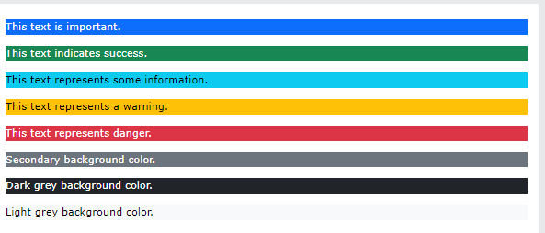

Basic Table

A basic Bootstrap 5 table has a light padding and horizontal dividers.

The .table class adds basic styling to a table:

<body>

<div class="container mt-3">// margin top

<h2>Basic Table</h2>

<p>The .table class adds basic styling (light padding and horizontal dividers) to a table:</p>

<table class="table">

<thead>

<tr>

<th>Firstname</th>

<th>Lastname</th>

<th>Email</th>

</tr>

</thead>

<tbody>

<tr>

<td>John</td>

<td>Doe</td>

<td>john@example.com</td>

</tr>

<tr>

<td>Mary</td>

<td>Moe</td>

<td>mary@example.com</td>

</tr>

<tr>

<td>July</td>

<td>Dooley</td>

<td>july@example.com</td>

</tr>

</tbody>

</table>

</div>

</body>

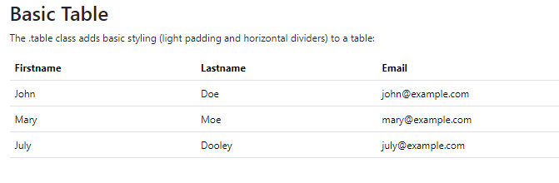

Striped Rows

The .table-striped class adds zebra-stripes to a table:

<table class="table table-bordered">

Bordered Table

The .table-bordered class adds borders on all sides of the table and cells:

Hover Rows

The .table-hover class adds a hover effect (grey background color) on table rows:

Black/Dark Table

The .table-dark class adds a black background to the table:

Dark Striped Table

Combine .table-dark and .table-striped to create a dark, striped table:

Hoverable Dark Table

The .table-hover class adds a hover effect (grey background color) on table rows:

Borderless Table

The .table-borderless class removes borders from the table:

Contextual Classes

[Contextual classes](https://www.w3schools.com/bootstrap5/bootstrap_colors.php) can be used to color the whole table (<table>),  the table rows (<tr>) or table cells (<td>).

Example

|  |  |  |
| --- | --- | --- |
| Default | Defaultson | def@somemail.com |
| Primary | Joe | joe@example.com |
| Success | Doe | john@example.com |
| Danger | Moe | mary@example.com |
| Info | Dooley | july@example.com |
| Warning | Refs | bo@example.com |
| Active | Activeson | act@example.com |
| Secondary | Secondson | sec@example.com |
| Light | Angie | angie@example.com |
| Dark | Bo | bo@example.com |

The contextual classes that can be used are:

| **Class** | **Description** |
| --- | --- |
| .table-primary | Blue: Indicates an important action |
| .table-success | Green: Indicates a successful or positive action |
| .table-danger | Red: Indicates a dangerous or potentially negative action |
| .table-info | Light blue: Indicates a neutral informative change or action |
| .table-warning | Orange: Indicates a warning that might need attention |
| .table-active | Grey: Applies the hover color to the table row or table cell |
| .table-secondary | Grey: Indicates a slightly less important action |
| .table-light | Light grey table or table row background |
| .table-dark | Dark grey table or table row background |

Table Head Colors

You can also use any of the contextual classes to only add a background color to the table header:

Small table

The .table-sm class makes the table smaller by cutting cell padding in half:

Responsive Tables

The .table-responsive class adds a scrollbar to the table when needed (when it is too big horizontally):

<div class="table-responsive">  
  <table class="table">  
    ...  
  </table>  
</div>

You can also decide when the table should get a scrollbar, depending on the screen width:

| **Class** | **Screen width** |
| --- | --- |
| .table-responsive-sm | < 576px |
| .table-responsive-md | < 768px |
| .table-responsive-lg | < 992px |
| .table-responsive-xl | < 1200px |
| .table-responsive-xxl | < 1400px |

Example

<div class="table-responsive-sm">  
  <table class="table">  
    ...  
  </table>  
</div>

Image Shapes

Rounded Corners

The .rounded class adds rounded corners to an image:

<div class="container mt-3">

<h2>Rounded Corners</h2>

<p>The .rounded class adds rounded corners to an image:</p>

<img src="ny.jpg" class="rounded" alt=" New York" width="304" height="236">

</div>

Circle

The .rounded-circle class shapes the image to a circle:

<img src="cinqueterre.jpg" class="rounded-circle" alt="Cinque Terre" width="304" height="236">

Aligning Images

Float an image to the left with the .float-start class or to the right with .float-end:

<div class="container mt-3">

<h2>Aligning images</h2>

<p>Use the float classes to float the image to the left or to the right:</p>

<img src="paris.jpg" class="float-start" alt="Paris" width="304" height="236">

<img src="paris.jpg" class="float-end" alt="Paris" width="304" height="236">

</div>

Centered Image

Center an image by adding the utility classes .mx-auto (margin:auto) and .d-block (display:block) to the image:

<h2>Centered Image</h2>

<p>Center an image by adding the utility classes .mx-auto (margin:auto) and .d-block (display:block) to the image:</p>

<img src="paris.jpg" class="mx-auto d-block" style="width:50%">

</div>

Responsive Images

Images come in all sizes. So do screens. Responsive images automatically adjust to fit the size of the screen.

Create responsive images by adding an .img-fluid class to the <img> tag. The image will then scale nicely to the parent element.

The .img-fluid class applies max-width: 100%; and height: auto; to the image:

<h2>Image</h2>

<p>The .img-fluid class makes the image scale nicely to the parent element (resize the browser window to see the effect):</p>

<img class="img-fluid" src="ny.jpg" alt="New York" width="1100" height="500">

</div>

Bootstrap 5 Jumbotron

A jumbotron was introduced in Bootstrap 3 as a big padded box for calling extra attention to some special content or information.

Jumbotrons are no longer supported in Bootstrap 5. **However**, you can use a <div> element and add special helper classes together with a color class to achieve the same effect:

Jumbotron Example

Lorem ipsum dolor sit amet, consectetur adipiscing elit, sed do eiusmod tempor incididunt ut labore et dolore magna aliqua. Ut enim ad minim veniam, quis nostrud exercitation ullamco laboris nisi ut aliquip ex ea commodo consequat..

<div class="mt-4 p-5 bg-primary text-white rounded">  
  <h1>Jumbotron Example</h1>  
  <p>Lorem ipsum...</p>  
</div>

Bootstrap 5 Alerts

Alerts

Bootstrap 5 provides an easy way to create predefined alert messages:

Alerts are created with the .alert class, followed by one of the contextual classes .alert-success, .alert-info, .alert-warning, .alert-danger, .alert-primary, .alert-secondary, .alert-light or .alert-dark:

<div class="container mt-3">

<h2>Alerts</h2>

<p>Alerts are created with the .alert class, followed by a contextual color classes:</p>

<div class="alert alert-success">

<strong>Success!</strong> This alert box could indicate a successful or positive action.

</div>

<div class="alert alert-info">

<strong>Info!</strong> This alert box could indicate a neutral informative change or action.

</div>

<div class="alert alert-warning">

<strong>Warning!</strong> This alert box could indicate a warning that might need attention.

</div>

<div class="alert alert-danger">

<strong>Danger!</strong> This alert box could indicate a dangerous or potentially negative action.

</div>

<div class="alert alert-primary">

<strong>Primary!</strong> Indicates an important action.

</div>

<div class="alert alert-secondary">

<strong>Secondary!</strong> Indicates a slightly less important action.

</div>

<div class="alert alert-dark">

<strong>Dark!</strong> Dark grey alert.

</div>

<div class="alert alert-light">

<strong>Light!</strong> Light grey alert.

</div>

</div>

Alert Links

Add the .alert-link class to any links inside the alert box to create "matching colored links":

Add the alert-link class to any links inside the alert box to create "matching colored links".

<div class="alert alert-success">

<strong>Success!</strong> You should <a href="#" class="alert-link">read this message</a>.

</div>

<div class="alert alert-info">

<strong>Info!</strong> You should <a href="#" class="alert-link">read this message</a>.

</div>

Closing Alerts

To close the alert message, add a .alert-dismissible class to the alert container. Then add class="btn-close" and data-bs-dismiss="alert" to a link or a button element (when you click on this the alert box will disappear).

<div class="alert alert-success alert-dismissible">  
  <button type="button" class="btn-close" data-bs-dismiss="alert"></button>  
  <strong>Success!</strong> This alert box could indicate a successful or positive action.  
</div>

Animated Alerts

The .fade and .show classes adds a fading effect when closing the alert message:

<div class="alert alert-success alert-dismissible fade show">

<button type="button" class="btn-close" data-bs-dismiss="alert"></button>

<strong>Success!</strong> This alert box could indicate a successful or positive action.

</div>

Button Styles

Bootstrap 5 provides different styles of buttons:

<button type="button" class="btn">Basic</button>  
<button type="button" class="btn btn-primary">Primary</button>  
<button type="button" class="btn btn-secondary">Secondary</button>  
<button type="button" class="btn btn-success">Success</button>  
<button type="button" class="btn btn-info">Info</button>  
<button type="button" class="btn btn-warning">Warning</button>  
<button type="button" class="btn btn-danger">Danger</button>  
<button type="button" class="btn btn-dark">Dark</button>  
<button type="button" class="btn btn-light">Light</button>  
<button type="button" class="btn btn-link">Link</button>

The button classes can be used on <a>, <button>, or <input> elements:

<a href="#" class="btn btn-success">Link Button</a>

<button type="button" class="btn btn-success">Button</button>

<input type="button" class="btn btn-success" value="Input Button">

<input type="submit" class="btn btn-success" value="Submit Button">

<input type="reset" class="btn btn-success" value="Reset Button">

</div>

Button Outline

Bootstrap 5 also provides eight outline/bordered buttons.

Move the mouse over them to see an additional "hover" effect:



<button type="button" class="btn btn-outline-primary">Primary</button>  
<button type="button" class="btn btn-outline-secondary">Secondary</button>  
<button type="button" class="btn btn-outline-success">Success</button>  
<button type="button" class="btn btn-outline-info">Info</button>  
<button type="button" class="btn btn-outline-warning">Warning</button>  
<button type="button" class="btn btn-outline-danger">Danger</button>

Button Sizes

Use the .btn-lg class for large buttons or .btn-sm class for small buttons:

Large Default Small

<button type="button" class="btn btn-primary btn-lg">Large</button>  
<button type="button" class="btn btn-primary">Default</button>  
<button type="button" class="btn btn-primary btn-sm">Small</button>

Block Level Buttons

To create a block level button that spans the entire width of the parent element, use the .d-grid "helper" class on the parent element:



<div class="d-grid">  
  <button type="button" class="btn btn-primary btn-block">Full-Width Button</button>  
</div>

If you have many block-level buttons, you can control the space between them with the .gap-* class:

<div class="d-grid gap-3">  
  <button type="button" class="btn btn-primary btn-block">Full-Width Button</button>  
  <button type="button" class="btn btn-primary btn-block">Full-Width Button</button>  
  <button type="button" class="btn btn-primary btn-block">Full-Width Button</button>  
</div>

Active/Disabled Buttons

A button can be set to an active (appear pressed) or a disabled (unclickable) state:

The class .active makes a button appear pressed, and the disabled attribute makes a button unclickable. Note that <a> elements do not support the disabled attribute and must therefore use the .disabled class to make it visually appear disabled.

<button type="button" class="btn btn-primary active">Active Primary</button>  
<button type="button" class="btn btn-primary" disabled>Disabled Primary</button>



Spinner Buttons

You can also add "spinners" to a button, which you will learn more about in our [BS5 Spinners Tutorial](https://www.w3schools.com/bootstrap5/bootstrap_spinners.php):

<button class="btn btn-primary">  
  <span class="spinner-border spinner-border-sm"></span>  
</button>  
  
<button class="btn btn-primary">  
  <span class="spinner-border spinner-border-sm"></span>  
  Loading..  
</button>  
  
<button class="btn btn-primary" disabled>  
  <span class="spinner-border spinner-border-sm"></span>  
  Loading..  
</button>  
  
<button class="btn btn-primary" disabled>  
  <span class="spinner-grow spinner-grow-sm"></span>  
  Loading..  
</button>

Spinners

To create a spinner/loader, use the .spinner-border class:

<div class="spinner-border"></div>

Colored Spinners

Use any **text color utilites** to add a color to the spinner:

<div class="spinner-border text-muted"></div>  
<div class="spinner-border text-primary"></div>  
<div class="spinner-border text-success"></div>

Growing Spinners

Use the .spinner-grow class if you want the spinner/loader to grow instead of "spin":

<div class="spinner-grow text-muted"></div>  
<div class="spinner-grow text-primary"></div>  
<div class="spinner-grow text-success"></div>  
<div class="spinner-grow text-info"></div>  
<div class="spinner-grow text-warning"></div>

Button Groups

Bootstrap 5 allows you to group a series of buttons together (on a single line) in a button group:

Use a <div> element with class .btn-group to create a button group:

<div class="btn-group">  
  <button type="button" class="btn btn-primary">Apple</button>  
  <button type="button" class="btn btn-primary">Samsung</button>  
  <button type="button" class="btn btn-primary">Sony</button>  
</div>

**Tip:** Instead of applying button sizes to every button in a group, use class .btn-group-lg for a large button group or the .btn-group-sm for a small button group:

<div class="btn-group btn-group-lg">  
  <button type="button" class="btn btn-primary">Apple</button>  
  <button type="button" class="btn btn-primary">Samsung</button>  
  <button type="button" class="btn btn-primary">Sony</button>  
</div>

Vertical Button Groups

Bootstrap 5 also supports vertical button groups:

Use the class .btn-group-vertical to create a vertical button group:

<div class="btn-group-vertical">  
  <button type="button" class="btn btn-primary">Apple</button>  
  <button type="button" class="btn btn-primary">Samsung</button>  
  <button type="button" class="btn btn-primary">Sony</button>  
</div>

Button Groups Side by Side

Button groups are "inline" by default, which makes them appear side by side when you have multiple groups:

<div class="btn-group">  
  <button type="button" class="btn btn-primary">Apple</button>  
  <button type="button" class="btn btn-primary">Samsung</button>  
  <button type="button" class="btn btn-primary">Sony</button>  
</div>  
  
<div class="btn-group">  
  <button type="button" class="btn btn-primary">BMW</button>  
  <button type="button" class="btn btn-primary">Mercedes</button>  
  <button type="button" class="btn btn-primary">Volvo</button>  
</div>

Nesting Button Groups & Dropdown Menus

Nest button groups to create dropdown menus (you will learn more about dropdowns in a later chapter):

<div class="btn-group">  
  <button type="button" class="btn btn-primary">Apple</button>  
  <button type="button" class="btn btn-primary">Samsung</button>  
  <div class="btn-group">  
    <button type="button" class="btn btn-primary dropdown-toggle" data-bs-toggle="dropdown">Sony</button>  
    <div class="dropdown-menu">  
      <a class="dropdown-item" href="#">Tablet</a>  
      <a class="dropdown-item" href="#">Smartphone</a>  
    </div>  
  </div>  
</div>

Badges

Badges are used to add additional information to any content:

Use the .badge class together with a contextual class (like .bg-secondary) within <span> elements to create rectangular badges. Note that badges scale to match the size of the parent element (if any):

<h1>Example heading <span class="badge bg-secondary">New</span></h1>  
<h2>Example heading <span class="badge bg-secondary">New</span></h2>  
<h3>Example heading <span class="badge bg-secondary">New</span></h3>  
<h4>Example heading <span class="badge bg-secondary">New</span></h4>  
<h5>Example heading <span class="badge bg-secondary">New</span></h5>  
<h6>Example heading <span class="badge bg-secondary">New</span></h6>

Contextual Badges



Use any of the contextual classes (.bg-*) to change the color of a badge:

<span class="badge bg-primary">Primary</span>  
<span class="badge bg-secondary">Secondary</span>  
<span class="badge bg-success">Success</span>  
<span class="badge bg-danger">Danger</span>  
<span class="badge bg-warning">Warning</span>  
<span class="badge bg-info">Info</span>  
<span class="badge bg-light">Light</span>  
<span class="badge bg-dark">Dark</span>

Pill Badges



Use the .rounded-pill class to make the badges more round:

<span class="badge rounded-pill bg-primary">Primary</span>  
<span class="badge rounded-pill bg-secondary">Secondary</span>  
<span class="badge rounded-pill bg-success">Success</span>  
<span class="badge rounded-pill bg-danger">Danger</span>  
<span class="badge rounded-pill bg-warning">Warning</span>  
<span class="badge rounded-pill bg-info">Info</span>  
<span class="badge rounded-pill bg-light">Light</span>  
<span class="badge rounded-pill bg-dark">Dark</span>

Badge inside an Element

An example of using a badge inside a button:

<button type="button" class="btn btn-primary">  
  Messages <span class="badge bg-danger">4</span>  
</button>

Basic Progress Bar

A progress bar can be used to show how far a user is in a process.

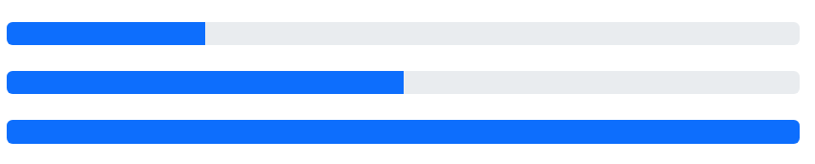

To create a default progress bar, add a .progress class to a container element and add the .progress-bar class to its child element. Use the CSS width property to set the width of the progress bar:

<div class="progress">  
  <div class="progress-bar" style="width:70%"></div>  
</div>

Progress Bar Height

The height of the progress bar is 1rem (usually 16px) by default. Use the CSS height property to change it:

<div class="progress" style="height:20px">  
  <div class="progress-bar" style="width:40%;"></div>  
</div>

Progress Bar Labels

Add text inside the progress bar to show the visible percentage:



<div class="progress">  
  <div class="progress-bar" style="width:70%">70%</div>  
</div>

Colored Progress Bars

By default, the progress bar is blue (primary). Use any of the contextual background classes to change its color:

<!-- Blue -->  
<div class="progress">  
  <div class="progress-bar" style="width:10%"></div>  
</div>  
  
<!-- Green -->  
<div class="progress">  
  <div class="progress-bar bg-success" style="width:20%"></div>  
</div>  
  
<!-- Turquoise -->  
<div class="progress">  
  <div class="progress-bar bg-info" style="width:30%"></div>  
</div>  
  
<!-- Orange -->  
<div class="progress">  
   <div class="progress-bar bg-warning" style="width:40%"></div>  
</div>  
  
<!-- Red -->  
<div class="progress">  
  <div class="progress-bar bg-danger" style="width:50%"></div>  
</div>  
  
<!-- White -->  
<div class="progress border">  
  <div class="progress-bar bg-white" style="width:60%"></div>  
</div>  
  
<!-- Grey -->  
<div class="progress">  
  <div class="progress-bar bg-secondary" style="width:70%"></div>  
</div>  
  
<!-- Light Grey -->  
<div class="progress border">  
  <div class="progress-bar bg-light" style="width:80%"></div>  
</div>  
  
<!-- Dark Grey -->  
<div class="progress">  
  <div class="progress-bar bg-dark" style="width:90%"></div>  
</div>

Striped Progress Bars

Use the .progress-bar-striped class to add stripes to the progress bars:

<div class="progress">  
  <div class="progress-bar progress-bar-striped" style="width:40%"></div>  
</div>

Animated Progress Bar



Add the .progress-bar-animated class to animate the progress bar:

<div class="progress-bar progress-bar-striped progress-bar-animated" style="width:40%"></div>

Multiple Progress Bars

Progress bars can also be stacked:



<div class="progress">  
  <div class="progress-bar bg-success" style="width:40%">  
    Free Space  
  </div>  
  <div class="progress-bar bg-warning" style="width:10%">  
    Warning  
  </div>  
  <div class="progress-bar bg-danger" style="width:20%">  
    Danger  
  </div>  
</div>

Basic List Groups

The most basic list group is an unordered list with list items:

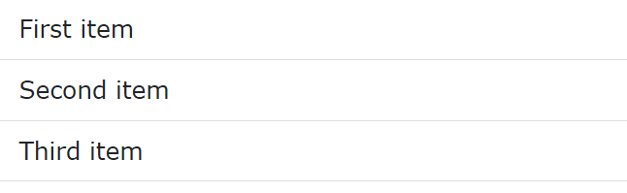

To create a basic list group, use an <ul> element with class .list-group, and <li> elements with class .list-group-item:

<ul class="list-group">  
  <li class="list-group-item">First item</li>  
  <li class="list-group-item">Second item</li>  
  <li class="list-group-item">Third item</li>  
</ul>

Active State

Use the .active class to highlight the current item:

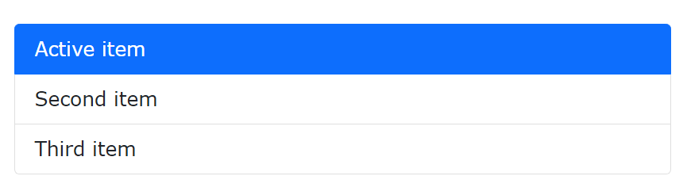

<ul class="list-group">  
  <li class="list-group-item active">Active item</li>  
  <li class="list-group-item">Second item</li>  
  <li class="list-group-item">Third item</li>  
</ul>

List Group With Linked Items

To create a list group with linked items, use <div> instead of <ul> and <a> instead of <li>. Optionally, add the .list-group-item-action class if you want a grey background color on hover:

<div class="list-group">  
  <a href="#" class="list-group-item list-group-item-action">First item</a>  
  <a href="#" class="list-group-item list-group-item-action">Second item</a>  
  <a href="#" class="list-group-item list-group-item-action">Third item</a>  
</div>

Disabled Item

The .disabled class adds a lighter text color to the disabled item. And when used on links, it will remove the hover effect:

<div class="list-group">  
  <a href="#" class="list-group-item disabled">Disabled item</a>  
  <a href="#" class="list-group-item disabled">Disabled item</a>  
  <a href="#" class="list-group-item">Third item</a>  
</div>

Flush / Remove Borders

Use the .list-group-flush class to remove some borders and rounded corners:

<ul class="list-group list-group-flush">  
  <li class="list-group-item">First item</li>  
  <li class="list-group-item">Second item</li>  
  <li class="list-group-item">Third item</li>  
  <li class="list-group-item">Fourth item</li>  
</ul>

Numbered List Groups

Use the .list-group-numbered class to create list items with numbers in front of them:

<ol class="list-group list-group-numbered">  
  <li class="list-group-item">First item</li>  
  <li class="list-group-item">Second item</li>  
  <li class="list-group-item">Third item</li>  
</ol>

Horizontal List Groups

If you want the list items to display horizontally instead of vertically (side by side instead of on top of each other), add the .list-group-horizontal class to .list-group:

<ul class="list-group list-group-horizontal">  
  <li class="list-group-item">First item</li>  
  <li class="list-group-item">Second item</li>  
  <li class="list-group-item">Third item</li>  
  <li class="list-group-item">Fourth item</li>  
</ul>

Contextual Classes

Contextual classes can be used to add color to the list items:

* Success item
* Secondary item
* Info item
* Warning item
* Danger item
* Primary item
* Dark item
* Light item

The classes for coloring list-items are: .list-group-item-success, list-group-item-secondary, list-group-item-info, list-group-item-warning, .list-group-item-danger, .list-group-item-primary, list-group-item-dark and list-group-item-light,:

<ul class="list-group">  
  <li class="list-group-item list-group-item-success">Success item</li>  
  <li class="list-group-item list-group-item-secondary">Secondary item</li>  
  <li class="list-group-item list-group-item-info">Info item</li>  
  <li class="list-group-item list-group-item-warning">Warning item</li>  
  <li class="list-group-item list-group-item-danger">Danger item</li>  
  <li class="list-group-item list-group-item-primary">Primary item</li>  
  <li class="list-group-item list-group-item-dark">Dark item</li>  
  <li class="list-group-item list-group-item-light">Light item</li>  
</ul>

Link items with Contextual Classes

<div class="list-group">  
  <a href="#" class="list-group-item list-group-item-action">Action item</a>  
  <a href="#" class="list-group-item list-group-item-action list-group-item-success">Success item</a>  
  <a href="#" class="list-group-item list-group-item-action list-group-item-secondary">Secondary item</a>  
  <a href="#" class="list-group-item list-group-item-action list-group-item-info">Info item</a>  
  <a href="#" class="list-group-item list-group-item-action list-group-item-warning">Warning item</a>  
  <a href="#" class="list-group-item list-group-item-action list-group-item-danger">Danger item</a>  
  <a href="#" class="list-group-item list-group-item-action list-group-item-primary">Primary item</a>  
  <a href="#" class="list-group-item list-group-item-action list-group-item-dark">Dark item</a>  
  <a href="#" class="list-group-item list-group-item-action list-group-item-light">Light item</a>  
</div>

List Group with Badges

Combine .badge classes with utility/helper classes to add badges inside the list group:

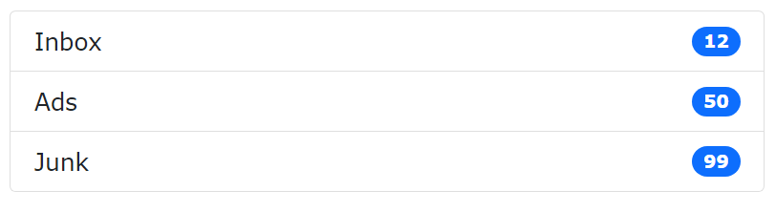

<ul class="list-group">  
  <li class="list-group-item d-flex justify-content-between align-items-center">  
    Inbox  
    <span class="badge bg-primary rounded-pill">12</span>  
  </li>  
  <li class="list-group-item d-flex justify-content-between align-items-center">  
    Ads  
    <span class="badge bg-primary rounded-pill">50</span>  
  </li>  
  <li class="list-group-item d-flex justify-content-between align-items-center">  
    Junk  
    <span class="badge bg-primary rounded-pill">99</span>  
  </li>  
</ul>

Select Menu

Select menu (select one):

Multiple select menu (hold ctrl or shift (or drag with the mouse) to select more than one):

Select menus are used if you want to allow the user to pick from multiple options.

To style a select menu in Bootstrap 5, add the .form-select class to the <select> element:

<select class="form-select">  
  <option>1</option>  
  <option>2</option>  
  <option>3</option>  
  <option>4</option>  
</select>

Select Menu Size

Use the .form-select-lg or .form-select-sm class to change the size of the select menu:

<select class="form-select form-select-lg">  
<select class="form-select">  
<select class="form-select form-select-sm">

Disabled Select Menu

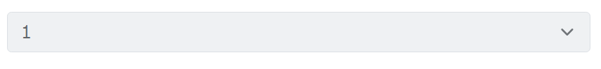

Use the disabled attribute to disable the select menu:

<select class="form-select" disabled>  
  <option>1</option>  
  <option>2</option>  
  <option>3</option>  
  <option>4</option>  
</select>

Data Lists

Bootstrap will also style data lists, which is a list of pre-defined options for an <input> element:

Choose your browser from the list:

<label for="browser" class="form-label">Choose your browser from the list:</label>  
<input class="form-control" list="browsers" name="browser" id="browser">  
<datalist id="browsers">  
  <option value="Edge">  
  <option value="Firefox">  
  <option value="Chrome">  
  <option value="Opera">  
  <option value="Safari">  
</datalist>

Navigation Bars

A navigation bar is a navigation header that is placed at the top of the page:

Basic Navbar

With Bootstrap, a navigation bar can extend or collapse, depending on the screen size.

A standard navigation bar is created with the .navbar class, followed by a responsive collapsing class: .navbar-expand-xxl|xl|lg|md|sm (stacks the navbar vertically on xxlarge, extra large, large, medium or small screens).

To add links inside the navbar, use either an <ul> element (or a <div>) with class="navbar-nav". Then add <li> elements with a .nav-item class followed by an <a> element with a .nav-link class:

Example

<!-- A grey horizontal navbar that becomes vertical on small screens -->  
<nav class="navbar navbar-expand-sm bg-light">  
  
  <div class="container-fluid">  
    <!-- Links -->  
    <ul class="navbar-nav">  
      <li class="nav-item">  
        <a class="nav-link" href="#">Link 1</a>  
      </li>  
      <li class="nav-item">  
        <a class="nav-link" href="#">Link 2</a>  
      </li>  
      <li class="nav-item">  
        <a class="nav-link" href="#">Link 3</a>  
      </li>  
    </ul>  
  </div>  
  
</nav>

<https://www.w3schools.com/bootstrap5/bootstrap_navs.php>

<https://www.w3schools.com/bootstrap5/bootstrap_navbar.php>

Stacked Form

All textual <input> and  <textarea> elements with class .form-control get proper form styling:

<form action="/action_page.php">  
  <div class="mb-3 mt-3">  
    <label for="email" class="form-label">Email:</label>  
    <input type="email" class="form-control" id="email" placeholder="Enter email" name="email">  
  </div>  
  <div class="mb-3">  
    <label for="pwd" class="form-label">Password:</label>  
    <input type="password" class="form-control" id="pwd" placeholder="Enter password" name="pswd">  
  </div>  
  <div class="form-check mb-3">  
    <label class="form-check-label">  
      <input class="form-check-input" type="checkbox" name="remember"> Remember me  
    </label>  
  </div>  
  <button type="submit" class="btn btn-primary">Submit</button>  
</form>

Also note that we add a .form-label class to each label element to ensure correct padding.

Checkboxes have different markup. They are wrapped around a container element with .form-check, and labels have a class of .form-check-label, while checkboxes and radio buttons use .form-check-input.

Textarea

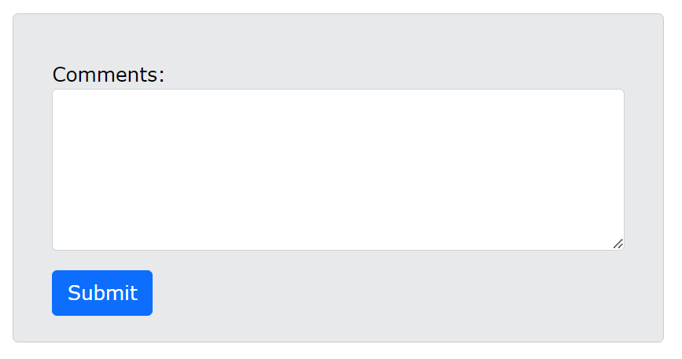

<label for="comment">Comments:</label>  
<textarea class="form-control" rows="5" id="comment" name="text"></textarea>

Form Row/Grid (Inline Forms)

If you want your form elements to appear side by side, use .row and .col:

<form>  
  <div class="row">  
    <div class="col">  
      <input type="text" class="form-control" placeholder="Enter email" name="email">  
    </div>  
    <div class="col">  
      <input type="password" class="form-control" placeholder="Enter password" name="pswd">  
    </div>  
  </div>  
</form>

You will learn much more about columns and rows in the [Bootstrap Grids Chapter](https://www.w3schools.com/bootstrap5/bootstrap_grid_system.php).

Form Control Size

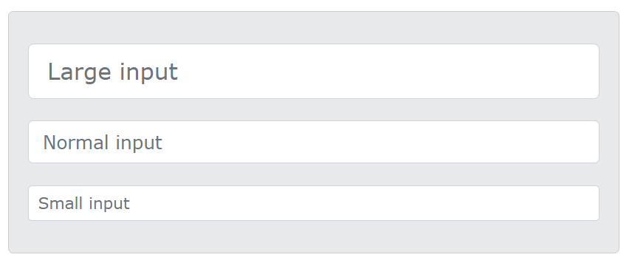

You can change the size of .form-control inputs with .form-control-lg or .form-control-sm:

Example

<input type="text" class="form-control form-control-lg" placeholder="Large input">  
<input type="text" class="form-control" placeholder="Normal input">  
<input type="text" class="form-control form-control-sm" placeholder="Small input">

[Try it Yourself »](https://www.w3schools.com/bootstrap5/tryit.asp?filename=trybs_form_size&stacked=h)

Disabled and Readonly

Use the disabled and/or readonly attributes to disable the input field:

<input type="text" class="form-control" placeholder="Normal input">  
<input type="text" class="form-control" placeholder="Disabled input" disabled>  
<input type="text" class="form-control" placeholder="Readonly input" readonly>

Plain text Inputs

Use the .form-control-plaintext class to style an input field without borders, but keep proper marigins and padding:

<input type="text" class="form-control-plaintext" placeholder="Plaintext input">  
<input type="text" class="form-control" placeholder="Normal input">

Color Picker

To style an input with type="color" properly, use the .form-control-color class:

<input type="color" class="form-control form-control-color" value="#CCCCCC">

Media objects:

<https://www.w3schools.com/bootstrap/bootstrap_media_objects.asp>

carousal /Slide show

<https://www.w3schools.com/bootstrap5/bootstrap_carousel.php>